Gilgit:

Kachura Lake

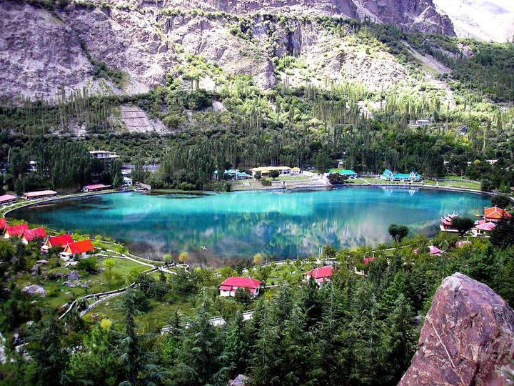

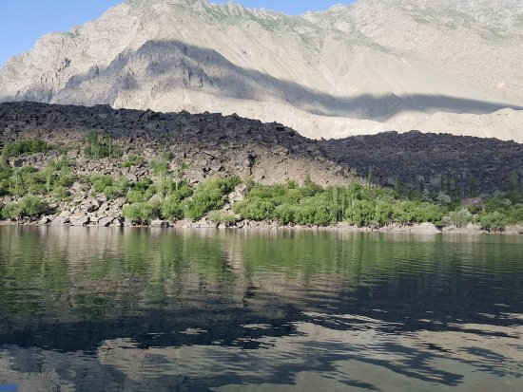

The **Kachura Lakes** are two lakes in the Skardu District of Gilgit-Baltistan, northern Pakistan. The lakes, at 2,500 metres (8,200ft) in elevation, are **Upper Kachura Lake** and **Lower Kachura Lake**. The latter is also known as Shangrila Lake and is within a tourist resort named Shangrila Resort outside the town of Skardu. The lakes are in the Karakoram mountain range of the western Himalayas, the greater Kashmir region, and in the Indus River basin.